Directions
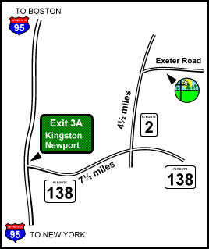

From I-95 North, take exit 3A onto Route 138 East.
The exit is marked for Kingston and Newport.
Drive for 7½ miles (7.5 miles) on Route 138 East.
Take a left onto Route 2 North.
The junction is at a set of lights.
Drive for 4½ miles (4.5 miles) on Route 2 North.
Take a right onto Exeter Road.
From this direction Exeter Road is marked with a Canonicus billboard.
The right turn is immediately after passing the Rhode Island Veteran's Cemetery on the left and a small group of stores and a post office on the right.

Canonicus Camp & Conference Center
54 Exeter Road
Exeter, RI 02822
Phone (800) 294-6318

Christ Presbyterian Church
Mini-Retreat
November 11-12, 2005

Gather round the fireplace for relaxing evening and enjoy the tranquil 300+ acres of meadow & woodland, with a picturesque lake. Experience the church as a "family of God" like this.
_____________________________________________________
The Itinerary

Friday Evening

8:00-8:30 pm Snacks
8:30-9:00 pm Worship/share/pray
9:00-9:30 pm Mixer
9:30- ??? Free Time

Saturday Morning
8:30-9:15 am Breakfast
9:30-10:15 am Bible Study
10:20-11:15 am Groups, Questions &
Prayer
11:15-12:00 Free Time
12-12:45 pm Lunch
1-3:00 pm Soccer Game
3-5:00 pm Free/Departure Time

__________________________________________________________

The Cost Half the price!
Adults $71.00 Children Ages 13 and up $71.00
Children Ages 4-12 $35.50 Children 3 and under free
Rooms can accommodate up to four individuals (to five). Each room has their own bathroom facilities. Full linen service is provided.

(Retreat directions listed on back)

(tear off here)-------------------------------------------------------------------------

REGISTRATION - YES ---- please sign me/us up.
Name(s): __________________________________________________________
Please indicate in the boxes provided how many individuals. Please place this part of registration on foyer table or collection basket today. Registration/payment is due by this Monday, November 7th.
◻ Adults $71.00 ◻ Children Ages 13 and up $71.00
◻ Children Ages 4-12 $35.50 ◻ Children 3 and under free

